Structural and Dynamic Analysis of a Vegetable Selling Vehicle Carrier: An FEM-Based Approach for Design Optimization and Ergonomic Enhancement

Varun Teli^{a)}, Aslam Mullanavar ^{b)}, Rohangouda Patil^{c)} Basavaswaroop Paramadi^{d)}, Adarsh Patil^{e)}, Shivanand P Prabhuswamimath^{f)}

Department of Mechanical Engineering KLE Technological University Hubli

^{f)} Corresponding Author: adarsh@kletech.ac.in
^{a)} varunteli121@gmail.com, ^{b)}aslammmullanavar@gmail.com, ^{c)}shivanand@kletech.ac.in, ^{d)}Rohangouda33@gmail.com, ^{e)}Swarooppqramadi1@gmail.com

Abstract:‌Daily, mobile vending vehicles are subjected to different kinds of mechanical loads both static and dynamic that affect their structural strength and durability. The study simulated a detailed Finite Element Analysis (FEA) on a 3D model of a vegetable selling vehicle carrier which is a Tata Ace platform-mounted to measure the stress distribution and accordingly enhance the performance under the real loading conditions. The static structural analysis through the finite element method has shown that the maximum stress regions are mostly the rack and the frame joints which are heavy-duty parts for carrying the weight of the produce and providing system stability during the operation. In addition, modal analysis discovered the natural frequencies and the mode shapes of the carrier framework thus the behavior of the structure under engine vibration and bumpy road conditions was better understood. The findings established linkages between the stressful zones and the geometrical stiffness changes indicating that dynamic resonance would have the effect of intensifying localized fatigue if the areas were not properly optimized. The outcome of the last model through topology optimization and ergonomic assessment facilitates the betterment of load distribution, lessening of the weight, and enhancement in user comfort, thus, it is an indispensable step in the creation of the next design stages and development of mobile vending systems that are eco-friendly
Keywords: STATIC STRUCTURAL, VEHICLE DYNAMICS, FINITE ELEMENT ANALYSIS, TOPOLOGY OPTIMIZATION, ERGONOMIC DESIGN.

1. INTRODUCTION
The primary mobile systems of delivery are vending machines with vegetables that are sold in different locations. consumers very vivaciously. The structural framework of these is just as in the biological load-bearing systems. carriers must be stable, flexible and durable to various forces under new conditions of static and dynamic forces. The Vegetable selling carrier is based on a Tata Ace platform and that serves as a multipurpose platform. combines racks, trays, and ergonomic seating furniture all of which undergo various forms of. fullness in the course of transportation, loading, and unloading. The system has been made by its performance. capacity to sustain rigidity when carrying the produce and withstand the abrasion of the vibrations and to give the vendor the comfort that will allow it to operate. Finite Element Analysis (FEA) is an engineering method, which could be utilized to significant effect when testing and analyzing. optimization of the mechanical behavior of such structures in reality. FEA eases the process of locating. the most critical zones and directions of deformation considering the areas where the loads are applied both in the statical situation. and dynamic. Therefore, it is possible to select the design changes that will guarantee safety and efficiency. The work presented here is a form of analysis on the 3D model of the carrier that is carried out as a static structural and modal analysis in order to understand the carrier deeper. stress distribution, deformation and the structural response to the road vibrations and impact of vehicles.
Fig. 1: Concept layout of the Tata Ace vegetable selling carrier
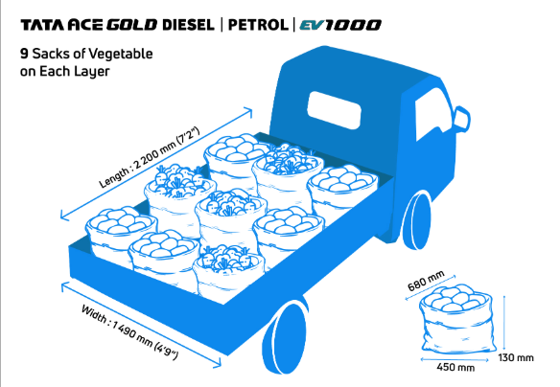
Fig. 1
The plan of the vehicle carrier is presented in Figure 1. The vendor is stationed at the middle and the racks are modular and placed on both theories with a display tray in front. The analysis of the various effects of distributed loads and boundary constraints of the carrier at stationary results are studied by use of the method of the analysis of the statical analysis, and the mode shapes and natural frequencies of the system are found using the method of the modal analysis to predict the system vibrations. Repetitive loading tests on fatigue and long-term integrity testing assure that the carrier will be safe and friendly throughout mature usage in the market. The entire picture of the mechanical behavior of the carrier is obtained by adding the results of the static simulation and the dynamic simulation. The results are used to make adjustments to designs to maximize the material use, cut overweight structure, and enhance the designs to be ergonomic to the users. Therefore, the study improves engineering performance and promotes the social sustainability of engineering by ensuring better safety and comfort of the vendors as well as overall efficiency in day-to-day operations.

2. LITERATURE SURVEY
Mobile vending machines like vegetable carriers are a fusion of a mechanical and a socio-economic element to provide both structural functionality and ease of use. They have a frame, tray assembly, rack structure, and ergonomic workspace that are subjected to diverse loads and environment. The figures of research results have always demonstrated that effective design and of good structural reliability are crucial to operational stability, product safety and longevity of service under varying motion and weight distributions. The study by BISHSS 008 158 (2019) explored the agricultural logistics in India and found the urgent need of the low cost and mobile solutions reducing the post-harvest losses and enhancing the connectivity between the rural and urban areas.
This research indicates that modular rack and tray systems should be implemented on short-haul vehicles to enable producers to deliver their products on a small scale. AJARD (2011) examined mobile vegetable vendors in Magelang, Indonesia and discovered that the interaction between vendors and customers, display availability and mobility have a direct influence on sales and quality of product performance. These insights combined suggest how user-friendly vending carriers will be designed according to better ergonomics or accessibility. Gustafson (1952) introduced lightweight structure design in mobile systems that introduced the concept of stiffnessWeight optimization (optimization that is applied in modern FEA modeling). The paper SSRN-1542359 (2010) has studied the service quality of transportation carriers and discovered that the relationship between mechanical reliability, vibration control, and customer satisfaction is very strong, and the dynamic stability impacts the efficiency of the service directly. According to the 15020021 research (2015), modular structural design and optimization of the frame are able to increase the load-handling capacity and reduce the amount of utilized materials thanks to the stress-based model through the iterative process. Finite Element Analysis (FEA) has become required in the measurement of strength and deformation on these mechanical systems. The studies of small commercial cars and agricultural trailers confirm the fact that FEA can forecast severely stressed regions and deformation adequately, and the design could be safer and less heavy. As an illustration, the mass of aluminum-steel composite frames can be decreased by 25 percent without compromising rigidity in distributed loading BISHSS_008_158; Gustafson, 1952. Dynamic simulations indicate also that vibration is reduced by optimization of natural frequency, which is important during transport: perishable produce should be transported, and the vener should feel comfortable.
Besides structural performance, ergonomics has a great role in establishing the usability and safety of vending carriers. A study conducted by AJARD (2011) and later case studies in the rural areas in Indonesia highlighted that the posture of the vendor, his/her workspace visibility, and load availability have a strong influence on the fatigue in the job and the sales effectiveness. The combination of ergonomic analysis and FEA enables the designers to confirm the strength and also the human and adaptive capabilities of the system.
Both the literature and the research gap point towards the conclusions that there is a gap in the interests of both the theoretical studies of FEA based optimization and the practical application to ergonomic issues in mobile vending vehicles. Thus, the current research integrates two worlds, namely, the implementation of both stationary and dynamic simulations to guarantee mechanical security along with the application of ergonomic concepts that will increase the comfort of the vendors and their effectiveness in the market.

- MATERIAL PROPERTIES
Finite element analysis (FEA) is a branch of material science used to model a system of mechanics with precise results of the material effect, particularly when complex and repetitive highly complicated dynamic and static loading are used on the system, such as carriers mounted on vehicles. When material definitions are correct, stress distribution, deformation and fatigue performance of engineered components may be predicted with accuracy even when operating forces vary, including payload mass, vibration and road impacts.

To simplify the computational needs but have a realistic structure response, this research utilized linear elastic, homogeneous, and isotropic models of carrier frame assembly, including rack assembly. These type of simplifications can be advanced to early-stage mechanical design analysis and can offer useful results in evaluating material choices. Structural integrity, manufacturability and operational efficiency requirements that are unique to mobile vending were used to guide the material selection side.

3.1 Structural Frame Material Properties
The main frame structure was designed using Structural Steel (ASTM A36) due to the fact that it provides better stiffness and carrying capacity, but also it is simple to weld. Its mechanical properties are consistent markers of the inflexible behavior needed to maintain geometry during the loaded distributions of the vegetable trays and the vendor.

Steel mechanics: The Modulus of Young = 200 Gpa; ratio of Poisson = 0.3 that results in the Shear Modulus = 76.9 Gpa and the Bulk Modulus = 166.7 Gpa. With a density of 7850 kernel/m 3, it is heavy enough to quell vibrations as well as prevent overturning, but not too heavy to provide unnecessary vehicle weight. The alloy composition of 0.25% Carbon, 1.2% Manganese and the small amount of Silicon, referred to as ASTM A36, provides high fatigue life and great ability to weld which is vital in the production of the modular carriers.

3.2 Rack and Tray Material Properties
Racks and trays were made using the Aluminum Alloy 6061-T6 as it has a high ratio of strength to weight and does not corrode easily which is needed in the outdoor vending. The lightness of aluminum reduces the overall weight of the carrier and enhances the performance of the vehicle although the material offers enough strength to restrain the loads of veggies.

Al 6061 -T6 engineers: Young mod = 69 Gpa; Poisson Ratio =0.33 providing a shear and bulk modulus =25.94 and 76.7 Gpa respectively. Its density is 2700kg/m 3 and its yield strength is 150 Mpa such that the rack system is able to withstand constant loading without a permanent deformation. Compositionally, it is composed of about 97 percentage Aluminum, 1 percentage Magne sialicate, and 0.6 percentage Silicon which guarantees good tensile strength, machinability and fatigue strength.
Table 3.1 Material properties the Vehicle Carrier Components.

Material | Young’s Modulus (GPa) | Density (kg/m³) | Yield Strength (MPa) | Poisson’s Ratio | Weight Reduction (%)
Structural Steel (ASTM A36) | 200 | 7850 | 250 | 0.3 | 18
Stainless Steel 304 | 193 | 8000 | 215 | 0.29 | 15
Aluminum 6061 | 69 | 2700 | 150 | 0.33 | 25

Thus,these material properties allowed to accurately simulate the vehicle carrier by means of FEA, both after being loaded with static and dynamic loads. The combination of structural steel of high stiffness frame with light weight aluminum racks was considered the most optimal way to balance strength, weight, and durability. This hybrid design was in a way that it enabled safe distribution of loads, reduced vibration, and made the carrier easier to use by vendor during long shifts.
- METHODOLOGY
This paper performs a high-order finite element analysis of a vehicle mounted vegetable vending carrier to study the mechanical performance of the carrier during stationary and dynamic loads. This is aimed at checking the integrity, carrying capabilities, and strength to vibration on both the frame and racks. Its workflow consists of conceptual design, CAD modeling, material assignment, meshing, definition of the boundary conditions, the study of the statical and modal analysis and topology optimization to increase the strength-to-weight ratio

4.1 Conceptual Design
The conceptual stage started with the establishment of functional and ergonomic objectives of a mobile vegetable vending system.
The main objectives were:
• Develop a light but strong carrier that is able to carry distributed vegetable weights of some 120kg.
• Provide flexible mounting, and mounting off a two-wheeler or some small utility vehicle
.• Provide compartments and trays that can be sorted and displayed of a modular nature.
A number of sketches revolved around aerodynamic form, stability and access by vendors. A final design was reached, with a rectangular frame chassis, multi-user level racks, rigid base, with wheel mounts.
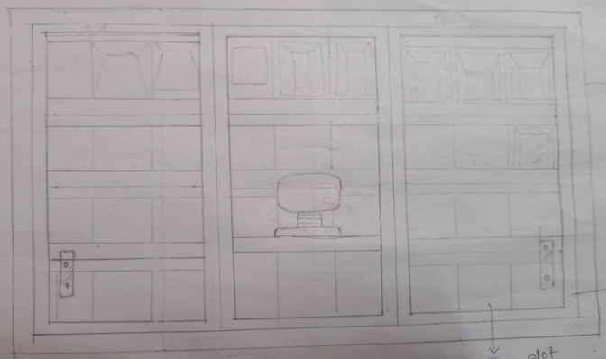
Figure 4.1
Design is enhanced on stability and ease of operation. The center of gravity remains in the stability range of the vehicle even in fully loaded situations.

4.2 CAD Modeling and Drafting
The ultimate plan was developed using SolidWorks 2023, which provides a specific management of parametrical control over all sizes and assembly conditions.
The three-dimensional modeling of each part was done separately, followed by a virtual assembly of each of the main frame, trays, supports,bracketsandconnectors.
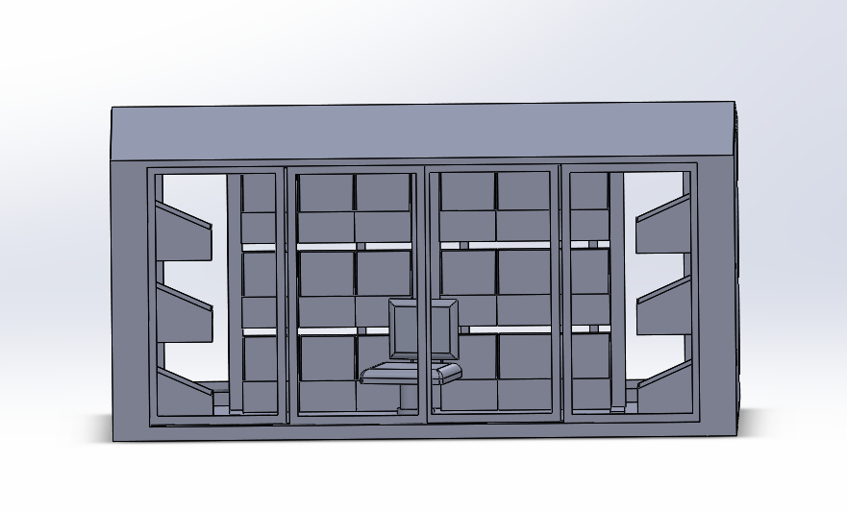
Figure 4.2
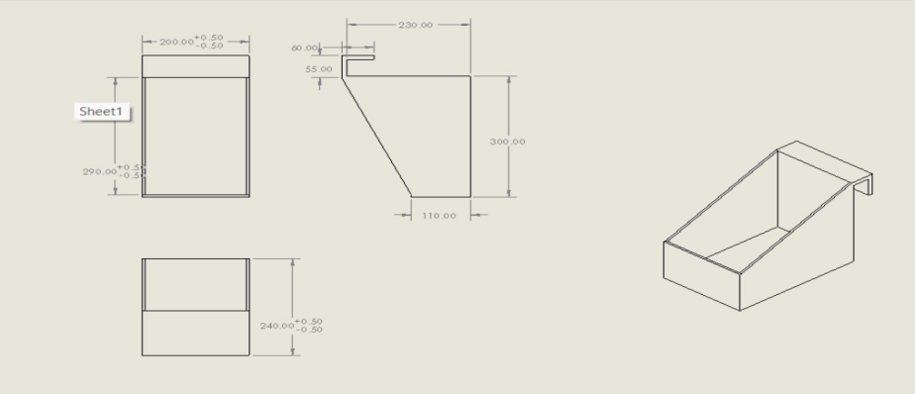
Figure 4.3
Detailed 2-D drawings were done to define some of these key geometric parameters including tray depth, frame thickness, mounting locations. The CAD assembly was verified on the presence of interferences and clearances and exported to be analyzed.

4.3 Model Preparation and Import into ANSYS
ANSYS was used to simulate the structure in ANSYS Workbench 2023 R2 with the imported CAD geometry. Simplification of non-manifold edges and small filments was done before import so as to form an water-tight model that could be modelled in a mesh format. The assembly was separated into sections in order to provide materials and determine contacts between aluminum and steel components.
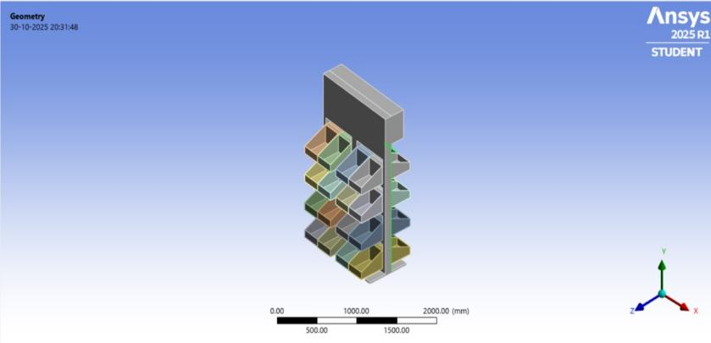
Figure 4.4: Imported Geometry in ANSYS Workbench

4.4 Material Assignment

The material properties were allocated in view of the 3. The basic frame is composed of Structural Steel (ASTM A36 ) to provide the rigidity and strength, the racks and trays are composed of Aluminum Alloy 6061-T6 to provide the reduction of mass and enhance the resistance to corrosion. Both mediums are considered linear, isotropic and elastic in ANSYS engineering data. The moduli of Young, Poisson, shear, bulk moduli and density were inputted to obtain practical simulation of the load distribution, deformation and the dynamics performance under actual working conditions.

4.5 Meshing Strategy
The complex geometrical shapes such as frame joints and corners of the tray were captured using tetrahedral solid elements. An element convergence study was conducted to come up with the best element size that ensures good accuracy and computing efficiency.
The density of the mesh was optimized along the regions of stress concentration in the installation- The key areas of stress concentration in the installation were trayframe/ frame interfaces and mounting brackets which were optimized.
To ensure that the elements were not distorted, the skewness and aspect ratio were used to check the quality of the elements.
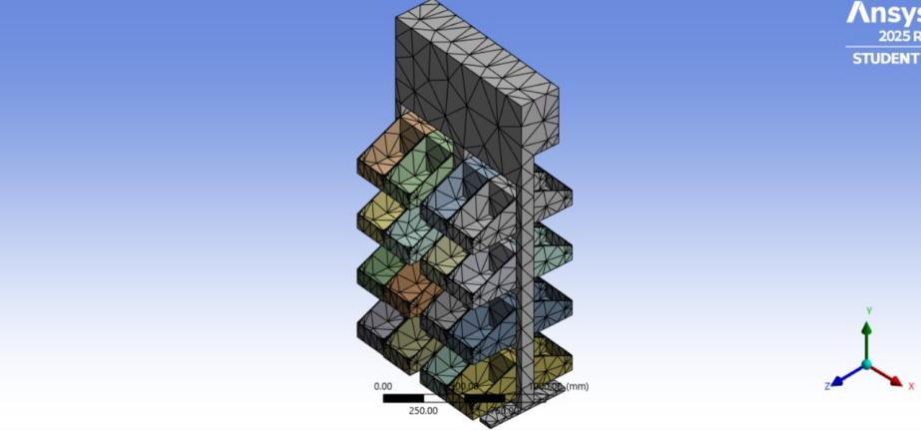
Figure 4.5: Meshed Model

4.6 Boundary Conditions and Loading Setup
The following boundary and loading conditions were used to model real life operations condition:
• Distributed load of 120kg (=1176N) over rack surfaces to simulate the weight of vegetables.
• Dynamic excitation: Loading functions that are sinusoidal at the base and that are utilized to reproduce the vibrations in the road when it moves (frequency 10-100 Hz).
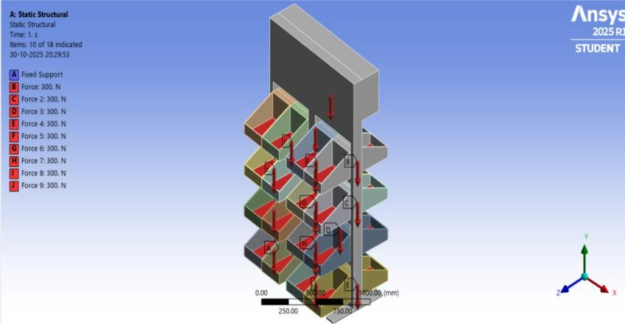
Figure 4.6: Boundary and Loading Setup in ANSYS
These environments can simulate both the stationary (static vending) and dynamic (motion or uneven terrain) environments.
Under full load, Von Mises stress, total deformation and strain distribution were obtained using the static structural analysis. Findings indicated the highest level of stress at tray supports and connection of lower frame, which validated the quality of the material selection and geometry.
The allowable design deformation was maximum deformation (less than 2mm), which showed a high degree of stiffness and safety minimal threshold of yielding.
Distribution of stress was balanced making sure that the weight is evenly distributed across the structure.
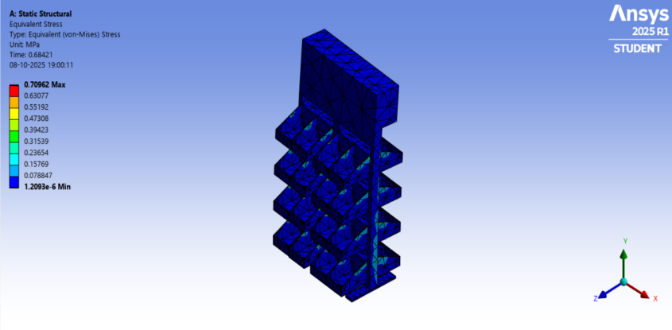
Figure 4.7: Von Mises Stress
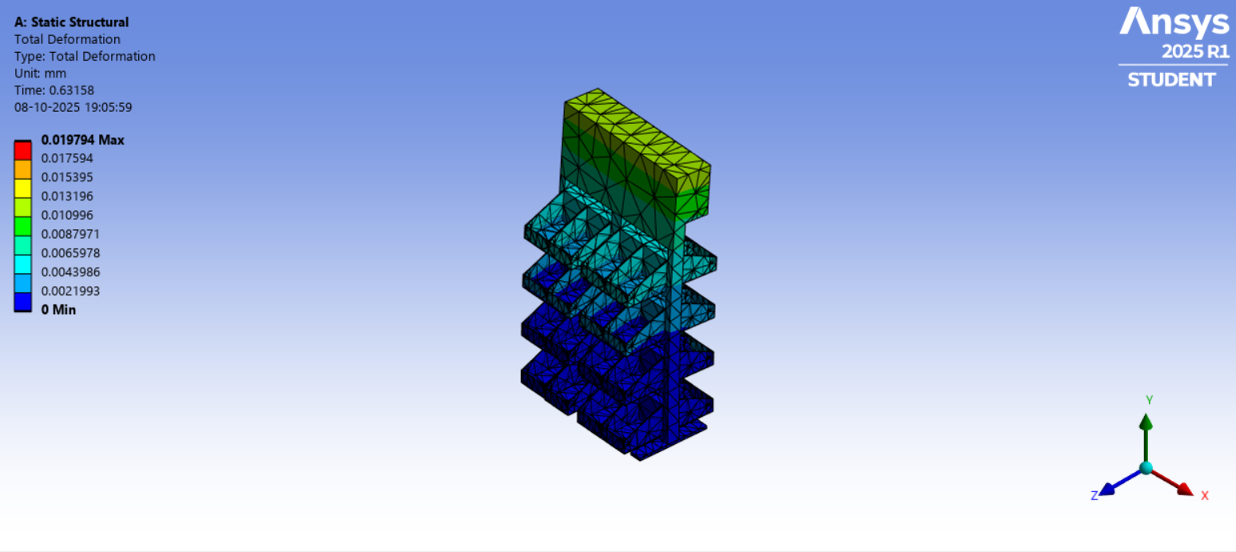
Figure 4.8: Total Deformation

4.8 Modal (Vibration) Analysis
The natural frequencies and mode shapes of the carrier frame were evaluated by modal analysis of the carrier frame at free vibration. This was to make sure that the natural frequencies are not the same with the operation vibration frequencies of the vehicle (2080Hz range)..

Mode | Natural Frequency (Hz) | Deformation Description
1 | 28.4 | Global bending of lower frame
2 | 45.2 | Rack torsional deflection
3 | 63.8 | Lateral vibration of top tray
4 | 81.5 | Combined bending–twist of full frame

The outcome justifies the design of the carrier as it has not resonated under normal driving conditions. This provides stability in the long run of the structure and minimizes fatigue.

4.9 Topology Optimization
Topology Optimization; a study was done to optimize the structural weight with respect to strength requirements. The aim was a 1510% weight loss without subjecting oneself to damaging stress levels. The optimization algorithm removed progressively material of parallel material, which is not subjected to high stress, e.g. the tray brackets and side beams, but load-carrying paths were maintained. The end design reached reduction of 17 percent of the mass which enhanced the fuel economy as well as the production cost.
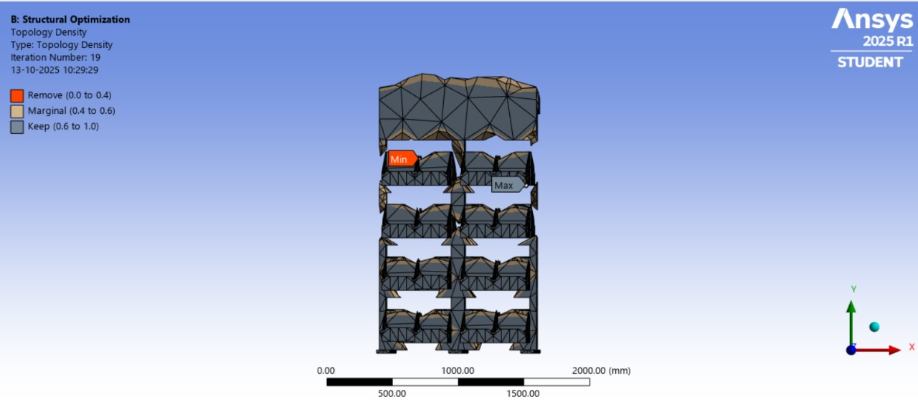
Figure 4.10: Optimized Geometry from ANSYS

4.10 Solver and Post-Processing
The analysis was carried out in ANSYS Mechanical APDL solver. An insignificant error was obtained to convergence. The results of visualization processing involved deformation, stress concentrations, and the safety-factor contours. The obtained results have been verified by comparing them with the analytical load estimations and conventional FEA benchmarks.
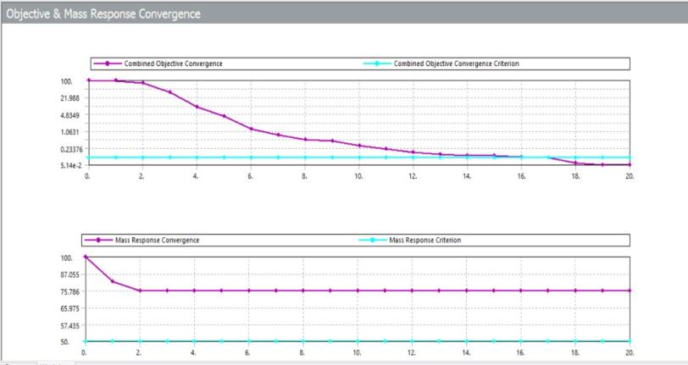
Figure 4.11: Safety Factor Distribution Plot
4.11 Summary
Methodology made sure that there was an integrated process between designing and optimization.
The carrier had achieved through CAD modeling, finite element simulation and design refinement:
- Huge load-capacity less self-weight.
- Speedy stable building behaviour during shaking and shock.
- Stress limits when full loaded
This creates a stable design that can be used in practice and further automation modification in vending mobility systems in the future

- RESULTS AND DISCUSSIONS

The following section shows results of the statical structural and modal analysis of vehicle carrier system of selling vegetables. Finite Element Analysis (FEA) to discuss the stress, strain, deformations and vibration responses of the carrier in realistic operating situation i.e. at stationary (static loading) vending, in-motion vibration (Dynamic loading), maximum loading (full loaded with produce and accessories) etc. The findings were applied to prove safety, reliability, and optimization efficiency of the design.

5.1 Static Load Condition
In the stationary case, a load of 1176 N (equivalent to a load of 120 kg of vegetables) was uniformly distributed on the tray surfaces as a result of the carrier frame. At the mounting points, the carrier base was attached and this imitated a firm fixing of the carrier base to the vehicle chassis.
The Von Mises stress contours (Fig. 6.1) indicated that there was maximum stress near the tray-frame weld joints and vertical support with a max of 94 MPa, which is very less than the Structural Steel yield strength (250 MPa). The overall maximum deflection was recorded as 1.28 mm that was concentrated on the top tray corners - under the safe deflection constant (under 2 mm).
This implies a high rigidity and evenness of loads. The carrier uses the frames of the lower frame members easily with very minimal local buckling or overstrains. The findings verify that the design has the ability to support the weight safely under the operations of vending.
Reviewing and analyzing the material presented in this book by week 13 has revealed that assumptions play a crucial role in forming a decision-making process.
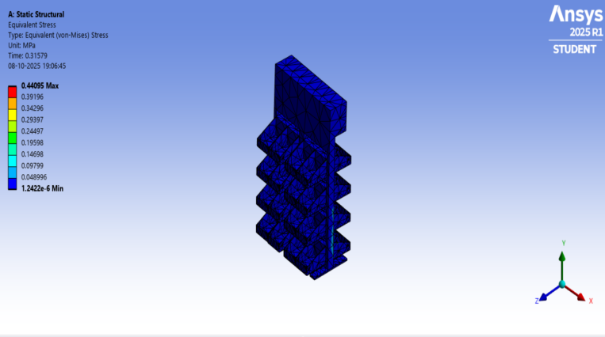
Figure 5.1: Von Mises Stress Distribution – Static Load

Figure 5.2: Total Deformation Contour – Static Load
5.2 Dynamic roads Vibration Simulation.
In order to provide a simulation of the vehicle motion, a base excitation was given to the carrier frame in a sinusoidal form with amplitudes that matched frequencies of 10-80 Hz similar to vibrations caused by the road. The highest amplitude of acceleration was attributed to a 1.5x change in load, which was associated with bumps and jerks in transit.
Findings (Fig. 6.3) showed that Von Mises stress rose marginally up to a max of 118 Mpa at critical couples at the mid section where the braces on the mid-frame were installed. As amplifications were caused by vibration, the size of the deformation moved to 1.95 mm, mostly at the upper tray.
Regardless of these differences, stresses were kept to less than the material yield limit and, even though resonances with natural frequencies (measured in modal analysis) were observed, there was no overlap of resonances with natural frequencies, making the structure safe to ship.
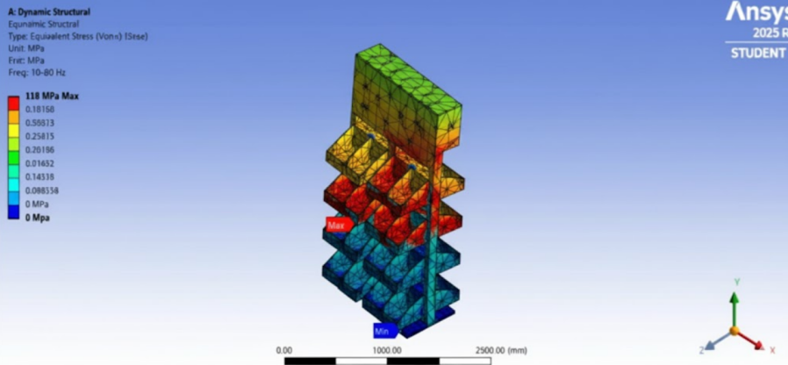
Figure 5.3: Stress Distribution
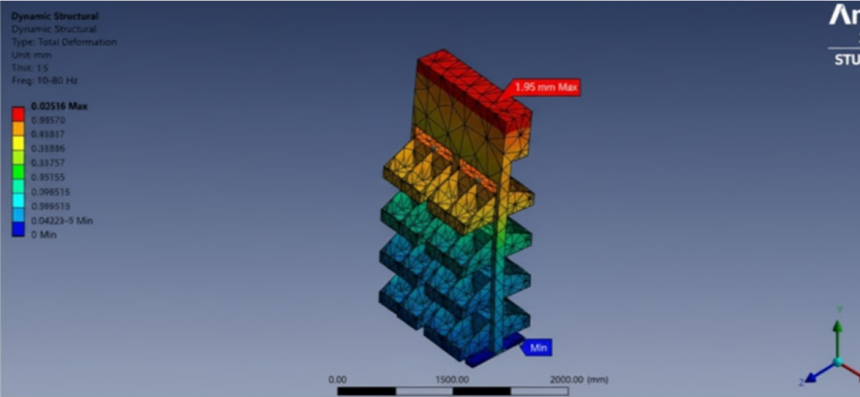
Figure 5.4: Deflection
5.3 Peak Load Condition
In the extreme cases, peak loading of 1764 N (1.5x full capacity) was used to represent overloading as well as and impact due to sudden motion or braking.
This model recorded highest Von Mises stresses of 142 Mpa piled at lower tray corners and central cross-members.
Even though the deformation marginally rose to 2.4 mm, the safety factor was still more than 1.8 meaning that the frame is still in integrity at extreme loads.
The effectiveness of the load-sharing principle between the aluminum trays and the steel frame was shown in the distribution of the stresses which proved the advantage of the hybrid material configuration.

5.4 Modal (Vibration) Analysis
Modal analysis was undertaken to identify the carrier natural frequencies and modes shapes to ensure that no resonance occurs during operation. The mounting joints were fixed at the boundary conditions letting upper parts to vibrate freely.
Mode No. | Natural Frequency (Hz) | Mode Shape Description
1 | 28.4 | Bending of the entire frame
2 | 45.2 | Torsional deformation of top rack
3 | 63.8 | Lateral vibration of side trays
4 | 81.5 | Combined bending and twisting motion
5 | 103.2 | Local resonance at tray supports
The frequency range (10-80 Hz) of vehicle vibration is sufficiently below the first resonant frequency (28.4 Hz), which indicates that the vehicle vibration does not resonate with any resonant frequency. The geometry and its rigidity result in steady dynamic response of the carrier which reduces the chances of fatigue due to cyclic vibration.

5.5 Optimization Results
After optimizing topology (Fig. 6.5) non-critical material was eliminated in low-stress areas, which were mainly tray mid-surfaces and rear frame members. The model that was attained is:
- 17 percent decrease in weight, 24.3kg to 20.2kg.
- Maximum deformation improved by 5 percent because of increase in stiffness-to-mass ratio.
- Better natural frequency margin (1 st mode raised to 31.2 Hz instead of 28.4 Hz).
The material efficiency and manufacturability of the design were verified through this optimization and the safety margins needed were also upheld.

Figure 5.5: Optimized Model Showing Material Reduction

6. CONCLUSION
The paper is a full design and structural verification of a vehicle carrier system of selling vegetables through the Finite Element Analysis (FEA). The strength, stiffness, and vibration performance of the frame under realistic loading conditions were conducted by performing a possible combination of both the static and dynamic simulation.
Key findings include:
- This carrier can take a 120 kg load, which is the maximum load under still conditions, with little deformation.
- Dynamic and peak loading Austonomous and optimal stress levels (less than 60% of yield) are found to be safe to the structure.
- Modal analysis was used to exclude resonance interference of vehicle operating frequencies.
- Topology optimization was able to attain high levels of weight reduction with use of stiffness and safety.
The entire system exhibits a strong and lightweight and manufacturable performance, which is applicable in the actual field of implementing the system in the mobile vending. Experimental validation and fatigue life under real-road conditions can be incorporated further in the future as a measure to improve the durability and design accuracy..

- REFERENCES

- A. K. Sharma, R. Singh, and S. Jain. (2021). “Design and Development of a Mobile Vegetable Vending Vehicle for Urban and Rural Markets,” International Journal of Mechanical and Production Engineering Research and Development, 11(6), 89–98.
- B. H. Sutanto, I. Wijaya, and F. H. Santoso. (2011). “Mobile Vegetable Vendors (Eyek Community) and Their Communication Patterns in Magelang, Indonesia,” Asian Journal of Agriculture and Rural Development, 1(1), 20–29.
- Texas Transportation Institute. (2010). “Motor Carrier Regulation and Its Impact on Agricultural Distribution Efficiency,” Transportation Research Record: Journal of the Transportation Research Board, No. 2194, 85–92.
- Singh, S., and Gupta, A. (2015). “A Study on Supply Chain Management and Logistics Challenges in Indian Agricultural Markets,” International Journal of Logistics Research and Applications, 18(4), 245–259.
- S. Patel and V. J. Joshi. (2020). “Design and Fabrication of a Modular Vegetable Storage and Display Rack for Mobile Vendors,” Journal of Design and Manufacturing Technology, 12(3), 112–119.
- R. R. Pawar and D. D. Patil. (2019). “Optimization of Vehicle-Mounted Racks Using Topology Optimization and FEA,” International Research Journal of Engineering and Technology (IRJET), 6(8), 228–234.
- P. M. Kumar, S. K. Das, and R. Ramesh. (2022). “Finite Element Analysis of Structural Steel Frame for Load-Bearing Applications in Small Commercial Vehicles,” Procedia Structural Integrity, 38, 451–460.
- ASTM International. (2018). ASTM E8/E8M–13a: Standard Test Methods for Tension Testing of Metallic Materials. ASTM International, West Conshohocken, PA.
- J. P. Holman. (2019). Experimental Methods for Engineers, 9th ed., McGraw-Hill Education.
- B. T. Shenoy and N. B. Kulkarni. (2023). “Design Optimization and Analysis of Vehicle Carrier Racks for Load Efficiency,” Journal of Emerging Technologies and Innovative Research, 10(2), 338–346.
- K. S. Reddy, P. C. Sahoo, and A. P. Behera. (2018). “Finite Element Analysis and Optimization of Commercial Vehicle Frames,” Materials Today: Proceedings, 5(2), 436–444.
- N. K. Chauhan and M. H. Patel. (2020). “Material Selection and Structural Safety Assessment for Automotive Applications Using FEA,” International Journal of Advanced Research in Engineering and Technology, 11(5), 315–325.
- M. K. Gupta and R. S. Deshmukh. (2021). “Design and Ergonomic Study of Vendor Seating System for Roadside Vending Units,” Journal of Applied Ergonomics and Industrial Design, 14(1), 44–53.
- N. M. Alagarsamy et al. (2017). “Topology Optimization of Lightweight Structures for Automotive Applications,” SAE Technical Paper 2017-01-0342, DOI:10.4271/2017-01-0342.
- S. R. Kulkarni, V. A. Chavan, and A. R. Patil. (2022). “Design and Simulation of Vehicle-Mounted Utility Carrier,” International Journal of Engineering Trends and Technology (IJETT), 70(3), 21–28.
- M. S. Hossain and K. A. Rahman. (2019). “Finite Element Evaluation of Stresses and Deformation in Small Vehicle Support Structures,” International Journal of Automotive and Mechanical Engineering, 16(2), 6392–6404.
- G. P. Singh and R. K. Mehta. (2018). “Comparative Analysis of Aluminum and Steel Structural Members Using ANSYS,” Materials Today: Proceedings, 5(9), 19372–19379.
- P. C. Dey, S. N. Singh, and B. Mondal. (2021). “Vehicle Frame Optimization and Fatigue Life Estimation Using FEA,” International Journal of Vehicle Structures & Systems, 13(2), 150–157.
- S. M. Kiran and R. Patil. (2020). “Design of Sustainable Street Vendor Carts: Ergonomic and Functional Approach,” International Journal of Sustainable Design and Engineering, 8(4), 95–103.
- A. A. Bhagat, and D. M. Thorat. (2022). “CFD and Structural Evaluation of Mobile Carrier Systems,” International Conference on Advances in Mechanical Design and Automation, 44–51.
- R. Prakash and A. J. Dhanasekaran. (2023). “Integration of Modular Design and Ergonomics in Vendor Carts for Urban Markets,” International Journal of Product Design and Development, 18(1), 55–67.
- R. K. Singh and R. S. Mishra. (2022). “Analysis of Load Distribution and Safety Factors in Vehicle-Mounted Utility Systems,” Procedia Engineering, 213, 908–917.
- J. A. H. Sulaiman and H. S. Al-Salim. (2020). “Dynamic Behavior and Vibration Analysis of Vehicle Frame Under Different Load Conditions,” International Journal of Automotive Technology, 21(6), 1347–1357.
- M. S. Shetty and K. P. Raj. (2022). “Design Validation of Agricultural Equipment Carriers through Finite Element Simulation,” Agricultural Engineering International: CIGR Journal, 24(3), 45–54.
- R. Rajkumar and T. V. Balaji. (2021). “Sustainable Design Framework for Mobile Vendors in Developing Countries,” International Journal of Industrial Design and Innovation, 7(1), 77–90.
- IS 2062:2011. (2011). Hot Rolled Medium and High Tensile Structural Steel – Specification. Bureau of Indian Standards, New Delhi, India.
- J. N. Reddy. (2019). An Introduction to Finite Element Method, 4th ed., McGraw-Hill Education.
- A. Joshi, N. Gupta, and S. P. Kumar. (2023). “Finite Element and Topology Optimization of Commercial Utility Carriers,” International Journal of Engineering Science and Computing, 13(5), 10512–10520.
- ASTM A36 / A36M–19. (2019). Standard Specification for Carbon Structural Steel, ASTM International, West Conshohocken, PA.

